AI-Based Smart Waste Segregation and Recycling Automation System
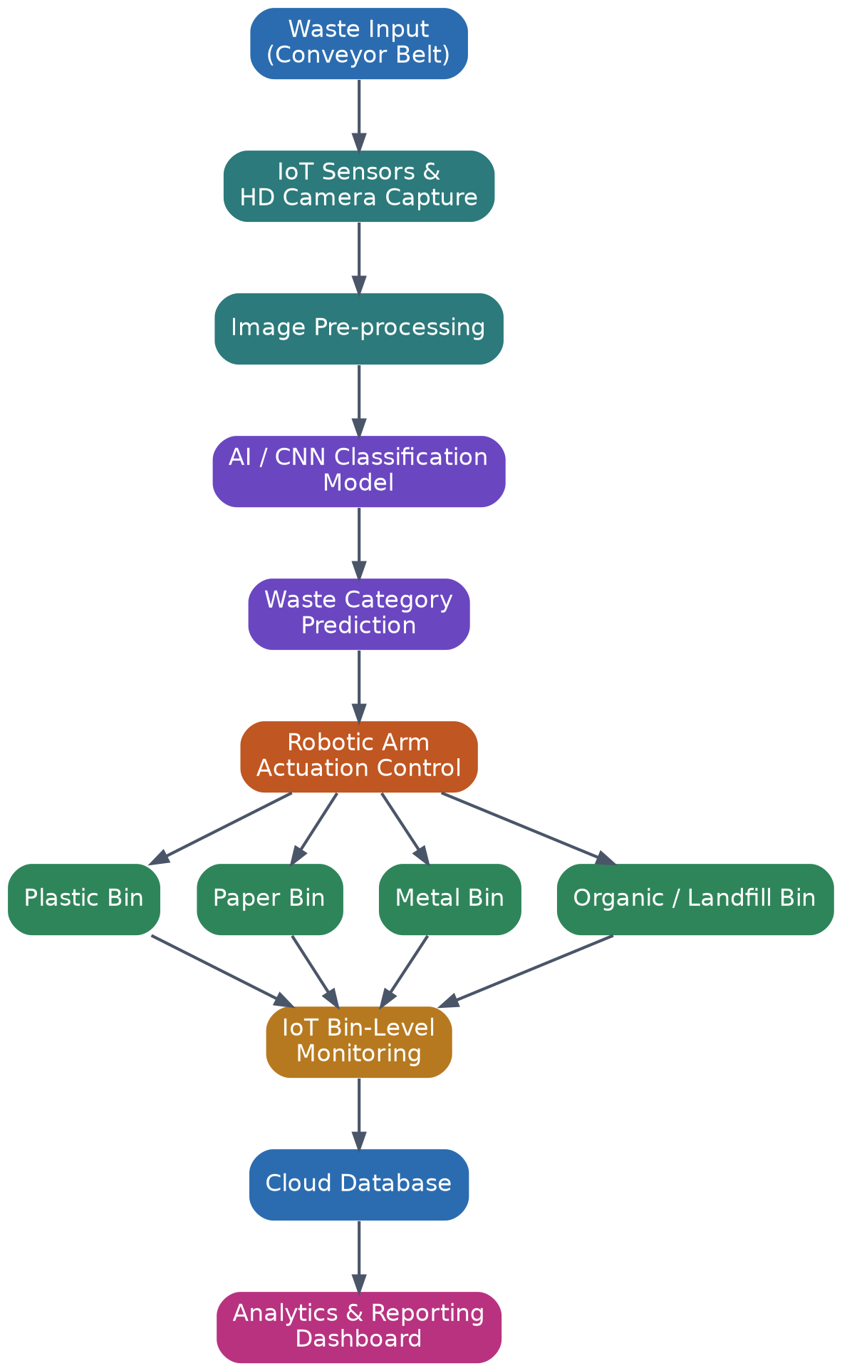
Domains: Artificial Intelligence | Computer Vision | Robotics | IoT
Sustainable Waste Management & Circular Economy Initiative

1. Industry Context
Efficient waste segregation is a cornerstone of sustainable waste management and recycling. As urban populations grow and consumption patterns intensify, municipal solid waste generation continues to rise sharply, placing enormous pressure on existing collection, processing, and disposal infrastructure. Recycling remains one of the most effective mechanisms for reducing environmental pollution, conserving natural resources, and supporting a circular economy in which materials are reused and reintroduced into production cycles rather than discarded.
Traditionally, waste segregation has depended heavily on manual labor. Workers at material recovery facilities sort mixed waste streams by hand, identifying plastics, paper, metals, glass, and organic material so they can be routed to the appropriate recycling or disposal channel. This approach is labor-intensive, physically demanding, and exposes workers to hazardous or unsanitary materials. It is also inherently inconsistent, since human judgment varies from worker to worker and fatigue reduces accuracy over the course of a shift.
The convergence of Artificial Intelligence, Computer Vision, Robotics, and the Internet of Things (IoT) now offers a practical path toward automating this process. Computer vision models can be trained to recognize and classify waste items in real time from camera imagery, while robotic manipulators can physically separate items into designated bins based on those classifications. IoT sensors extend this capability further by monitoring bin fill levels, equipment health, and throughput, feeding continuous data into cloud-based analytics platforms. Together, these technologies form the foundation of a smart, automated waste segregation and recycling ecosystem that directly supports circular economy initiatives worldwide.

2. Problem Statement
Improper segregation of municipal waste significantly reduces recycling efficiency and increases the volume of material sent to landfills. When recyclable materials are contaminated by mixed waste streams or misclassified during manual sorting, they are frequently rejected by recycling facilities and diverted to landfill sites, undermining recycling program goals and accelerating environmental degradation.
Existing waste processing facilities largely rely on manual sorting lines, which produce inconsistent results depending on staffing levels, training, and fatigue. This inconsistency translates directly into higher operational costs, lower material recovery rates, and greater environmental impact through increased landfill usage and associated greenhouse gas emissions from decomposing organic waste.
There is a clear need for an AI-powered waste segregation system capable of identifying different categories of waste using computer vision, automating the physical sorting process through robotic mechanisms, continuously monitoring recycling statistics, and generating comprehensive waste management reports for facility operators and municipal authorities. Such a platform must improve recycling efficiency while simultaneously reducing environmental pollution and the operational burden on human workers.

3. Proposed System Architecture
The proposed system integrates four functional layers: a sensing and image-capture layer, an AI classification layer, a robotic actuation layer, and a cloud analytics layer. Waste items move along a conveyor belt where IoT sensors and high-definition cameras capture continuous imagery. This imagery is passed to a trained AI classification model, which determines the waste category. A robotic arm then physically sorts each item into the corresponding bin, while bin-level IoT sensors and a cloud database track volumes and generate analytics for reporting dashboards.

Figure 1: End-to-end system architecture of the AI-based waste segregation platform
This layered architecture ensures that each subsystem can be independently upgraded or scaled. For example, the AI classification model can be retrained with new waste categories without altering the robotic hardware, and additional sorting stations can be added along the conveyor line to increase throughput as facility demand grows.

4. AI Waste Classification Workflow
At the core of the platform is a convolutional neural network (CNN) trained on labeled image datasets covering common waste categories such as plastic, paper, metal, glass, and organic material. When an item is detected on the conveyor belt, the system captures an image, applies noise removal and normalization, and extracts visual features that are passed through the classification model. If the model's confidence score meets the required threshold, the robotic arm is triggered to sort the item automatically; otherwise, the item is routed to a manual review queue to preserve overall accuracy.
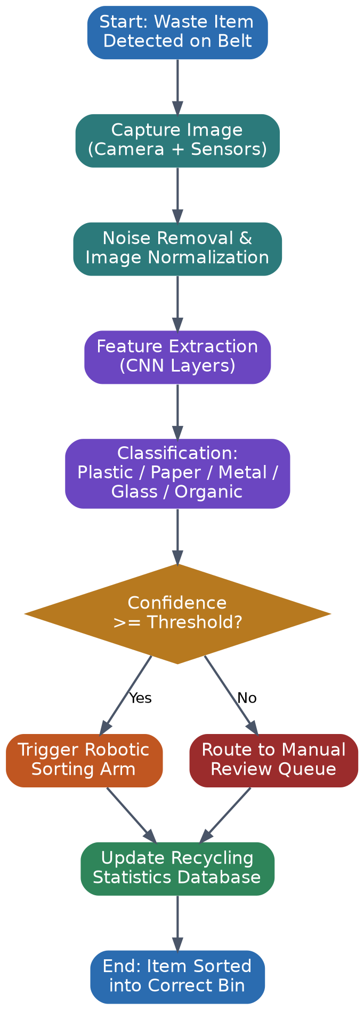
Figure 2: Step-by-step AI waste classification and sorting decision workflow

5. Objectives
The system is designed to achieve the following core objectives:
- Classify waste using AI-based computer vision models.
- Automate waste segregation through robotic sorting mechanisms.
- Monitor recycling operations continuously via IoT sensors.
- Reduce landfill waste by maximizing accurate material recovery.
- Generate detailed waste analytics reports for stakeholders.
- Improve overall recycling efficiency across processing facilities.
- Support broader environmental sustainability goals.
- Minimize manual intervention and associated labor risks.

6. Core Technology Components
The platform is built on a combination of hardware and software components spanning perception, decision-making, and action, summarized below.
Layer | Component | Function
Sensing | HD cameras, weight & proximity sensors | Capture waste imagery and physical properties
AI / Vision | CNN-based classification model | Identify waste category from image data
Robotics | Robotic arm / actuator array | Physically sort items into correct bins
IoT | Bin-level fill sensors, connectivity modules | Monitor bin status and equipment health
Cloud / Analytics | Database, dashboard, reporting engine | Store data, generate reports and insights

7. Recycling Monitoring & Analytics
Beyond physical sorting, the platform continuously logs data on every processed item, including its classified category, sorting confidence score, and timestamp. This data feeds a real-time analytics dashboard that gives facility operators visibility into waste composition trends, bin fill levels, and system throughput, enabling proactive maintenance and capacity planning.
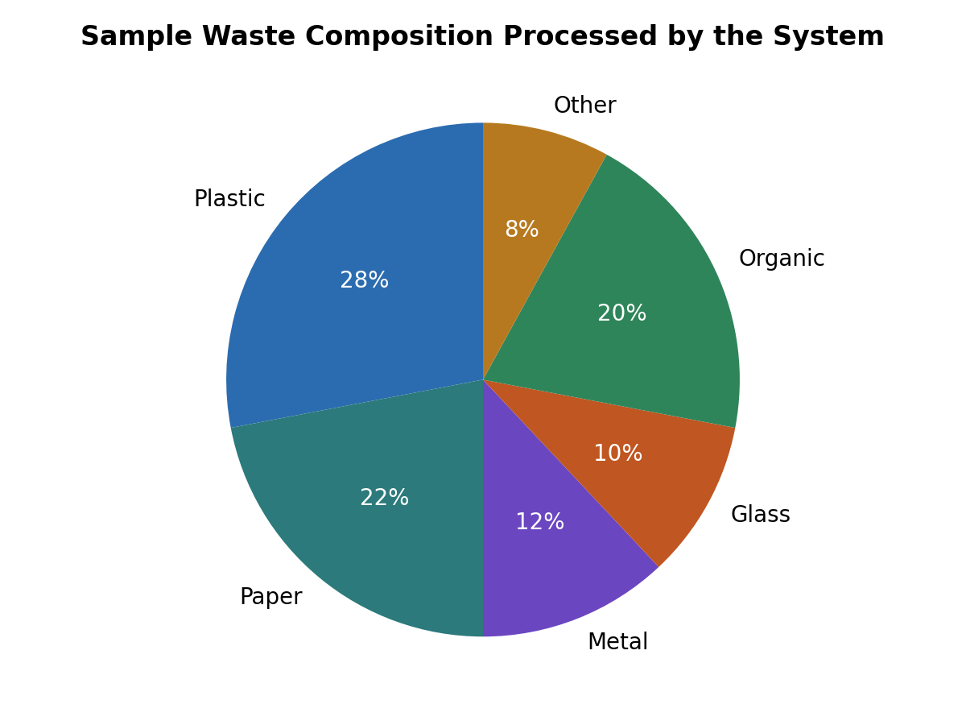
Figure 3: Sample breakdown of waste composition processed by the system
Aggregated analytics also support automated waste management reports, summarizing recycling rates, sorting accuracy, and volumes diverted from landfill over daily, weekly, and monthly periods. These reports can be shared with municipal authorities and facility managers to support regulatory compliance and continuous improvement initiatives.
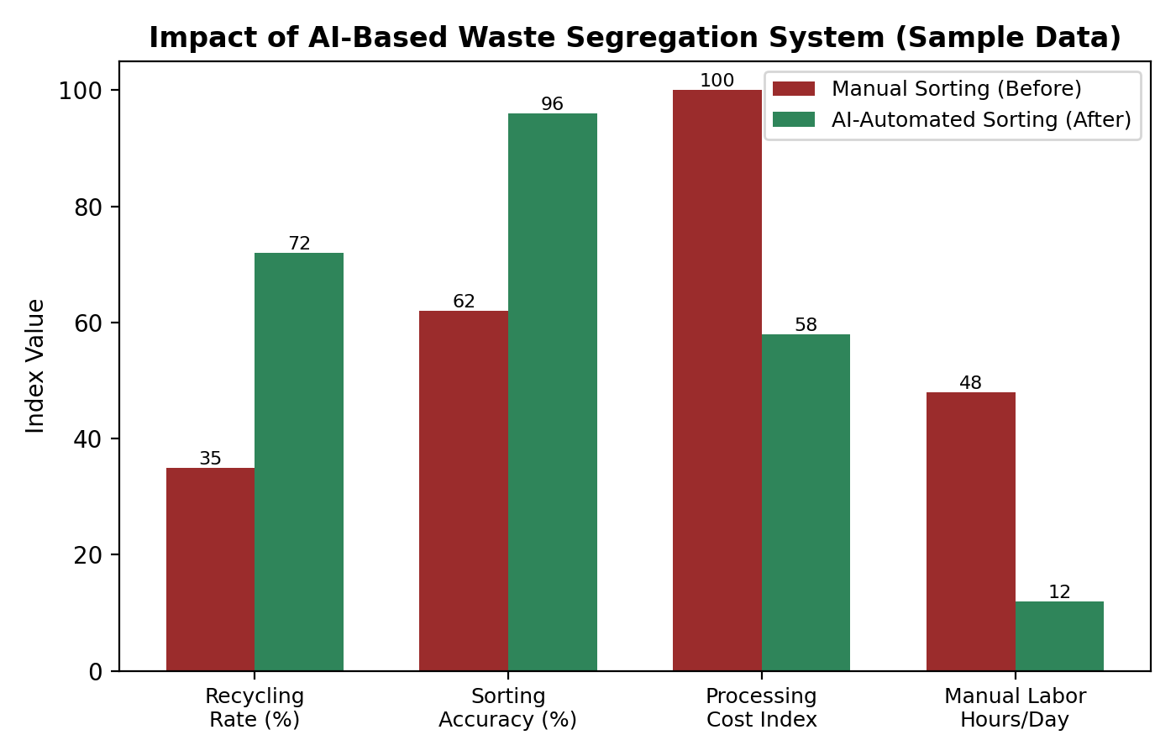
Figure 4: Illustrative comparison of manual versus AI-automated sorting performance

8. Expected Outcomes
8.1 Increased Recycling Rates
AI accurately identifies recyclable materials such as plastic, paper, metal, and glass, resulting in higher recycling rates and reduced material wastage.

8.2 Reduced Landfill Waste
Proper waste segregation ensures that recyclable materials are recovered instead of being dumped in landfills, reducing environmental pollution.

8.3 Lower Waste Processing Costs
Automation reduces the need for manual sorting, lowering labor costs while increasing processing speed and overall efficiency.

8.4 Improved Waste Segregation Accuracy
Computer Vision and AI classify waste more accurately than manual methods, reducing human errors and improving recycling quality.

8.5 Enhanced Environmental Protection
The system helps reduce pollution, conserve natural resources, and lower carbon emissions by promoting efficient recycling practices.

8.6 Sustainable Waste Management
By supporting the circular economy, the system encourages the reuse and recycling of materials, leading to long-term sustainable waste management.

8.7 Better Resource Recovery
Proper segregation increases the recovery of valuable recyclable materials, providing quality resources for recycling industries.

8.8 Increased Operational Efficiency
Real-time monitoring, automated sorting, and analytics reports improve the overall performance of waste processing facilities and support better decision-making.

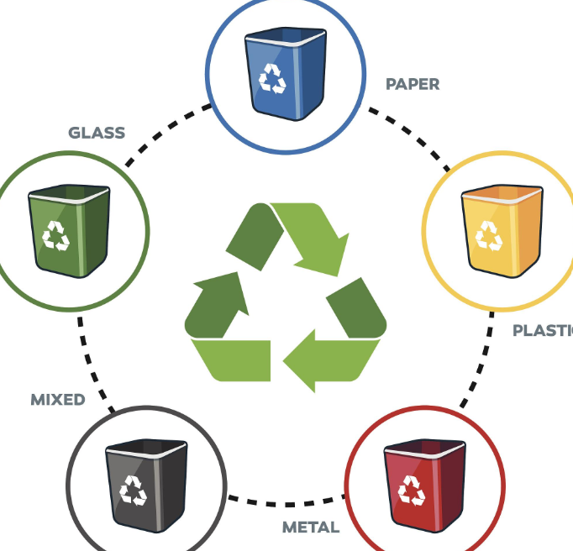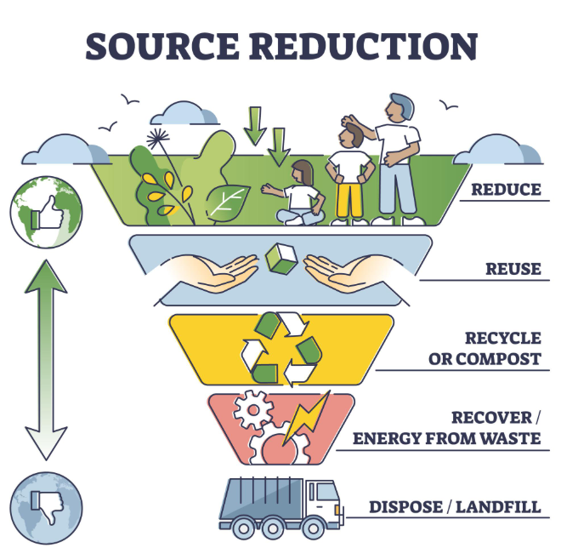

9. Implementation Considerations
Deploying this system at scale requires careful attention to model training data quality, since classification accuracy depends directly on the diversity and volume of labeled waste images used during training. Facilities should plan for periodic model retraining as new packaging materials and waste types enter the stream. Robotic hardware must also be selected for durability in harsh, contaminated environments, and IoT connectivity should include redundancy to ensure uninterrupted monitoring.
A phased rollout is recommended: beginning with a pilot line handling a limited set of waste categories, followed by iterative expansion of classification categories and sorting stations as accuracy and throughput targets are validated. This approach minimizes capital risk while allowing operational teams to build familiarity with the platform.
Facility layout also plays an important role in system performance. Conveyor speed must be tuned so that the AI classification and robotic actuation cycle can complete within the available detection window, and sorting stations should be spaced to avoid mechanical interference between adjacent robotic arms. Environmental factors such as lighting consistency and dust accumulation on camera lenses should be addressed through enclosure design and scheduled maintenance routines.

10. Key Challenges and Mitigation Strategies
Challenge | Mitigation Strategy
Visually similar materials (e.g., plastic vs. glass) | Combine visual data with weight and near-infrared sensors for multi-modal classification
Contaminated or overlapping waste items | Route low-confidence items to a manual review queue instead of forcing a sort
Model drift as new packaging types emerge | Scheduled retraining pipeline using newly labeled facility data
Hardware wear in harsh operating conditions | Ruggedized enclosures and predictive maintenance via IoT health sensors
High upfront capital cost | Phased pilot rollout with incremental expansion based on validated ROI

11. Future Enhancements
Once the core platform is established, several enhancements can further extend its value. Integrating predictive analytics can help facilities forecast incoming waste volumes and optimize staffing and logistics accordingly. Expanding the classification model to detect hazardous or electronic waste would allow the system to flag items requiring specialized handling rather than routing them through standard recycling streams.
Longer term, connecting multiple facility deployments through a shared cloud platform would allow municipal authorities to compare performance across sites, identify best practices, and benchmark recycling outcomes at a city or regional level. Coupled with citizen-facing dashboards, this data could also support public awareness campaigns that encourage better waste separation habits at the source, further reducing the burden on downstream automated sorting systems.
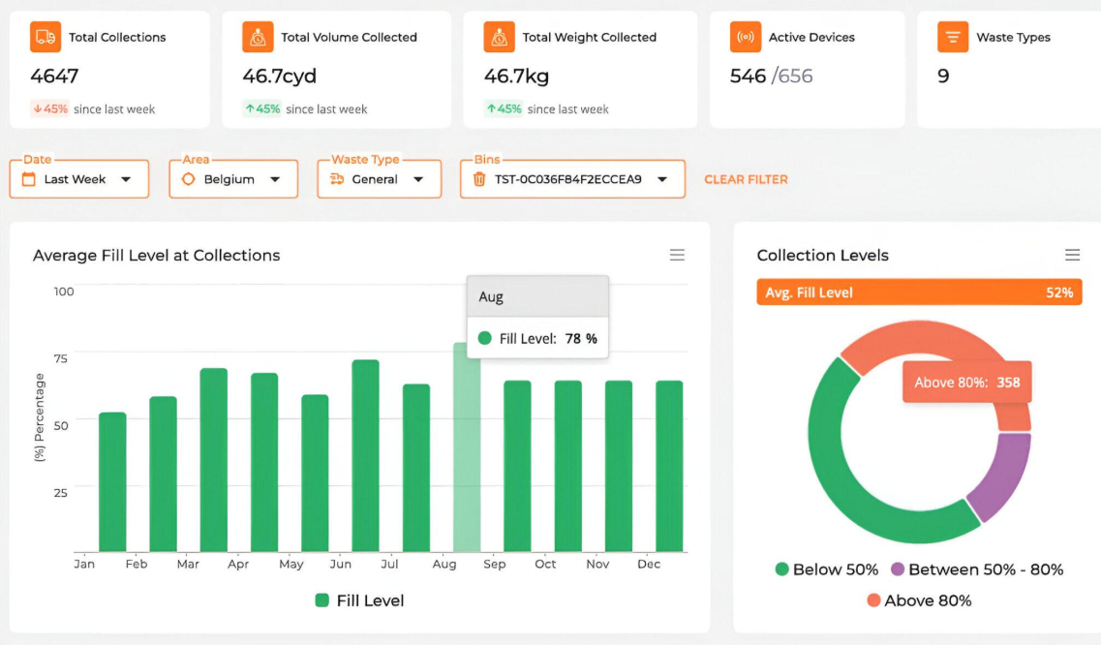
The proposed AI-Based Smart Waste Segregation and Recycling Automation System can be further enhanced to improve its efficiency, scalability, and environmental impact.
One major enhancement is the integration of predictive analytics to forecast waste generation based on historical data and seasonal trends. This will help waste management facilities optimize staffing, transportation, and processing capacity, reducing operational costs and improving efficiency.
The AI model can also be expanded to identify hazardous waste, electronic waste (e-waste), and medical waste in addition to recyclable materials. Detecting these waste types will ensure safe handling, proper disposal, and compliance with environmental regulations.
Another future improvement is the development of a cloud-based platform that connects multiple waste management facilities. This will allow municipal authorities to monitor recycling performance, compare results across different locations, and make data-driven decisions to improve waste management practices.
The system can also be integrated with IoT-enabled smart bins and robotic sorting systems to automate waste collection and segregation further. Smart bins can monitor fill levels and optimize collection routes, while robotic arms can improve sorting speed and accuracy.

12. Conclusion
The proposed AI-Based Smart Waste Segregation and Recycling Automation System offers an innovative and practical solution to one of the biggest challenges in modern waste management—the slow, inconsistent, and labor-intensive process of manual waste segregation. By combining Artificial Intelligence (AI), Computer Vision, Robotics, and IoT technologies into a single intelligent platform, the system can automatically detect, classify, and separate different types of waste with high accuracy and efficiency. This significantly reduces human error while ensuring recyclable materials are recovered effectively.
One of the most significant advantages of the proposed system is its ability to increase recycling rates by accurately identifying recyclable materials such as plastic, paper, glass, and metal before they reach landfills. This improves the quality of recycled materials and supports industries that depend on recovered resources. At the same time, the system helps reduce landfill waste, minimizing environmental pollution, greenhouse gas emissions, and the unnecessary use of natural resources.
The integration of robotic automation further improves the waste segregation process by reducing dependence on manual labor. Automated sorting not only increases processing speed but also enhances worker safety by limiting direct contact with hazardous or contaminated waste. In addition, IoT-enabled sensors continuously monitor system performance, equipment status, and waste flow, providing real-time data that enables better decision-making, predictive maintenance, and efficient resource utilization.
Another key strength of the proposed system is its modular and scalable architecture. New AI models, additional waste categories such as hazardous waste and electronic waste (e-waste), and advanced technologies can be integrated without redesigning the entire system. This flexibility allows the solution to grow with increasing waste volumes and adapt to the changing needs of municipalities, industries, and recycling facilities.
Beyond improving operational efficiency, the system also contributes to broader environmental and social benefits. By promoting proper waste segregation, reducing pollution, conserving natural resources, and encouraging responsible recycling practices, it supports the principles of the circular economy. The data generated by the system can also help government agencies and municipal authorities make informed decisions, optimize waste management policies, and improve recycling infrastructure.
Key Highlights of the Proposed System
- Higher recycling efficiency through AI-based waste identification and sorting.
- Reduced landfill dependency by recovering more recyclable materials.
- Automated and accurate segregation using computer vision and robotic systems.
- Real-time monitoring and analytics with IoT-enabled sensors and dashboards.
- Lower operational costs by minimizing manual labor and improving resource utilization.
- Enhanced environmental sustainability through reduced pollution and better resource conservation.
- Scalable and future-ready architecture capable of supporting new technologies and waste categories.
- Supports smart city initiatives by enabling intelligent, data-driven waste management.
In conclusion, the proposed system represents a significant step toward the future of intelligent waste management. By integrating advanced technologies with sustainable recycling practices, it not only improves operational performance but also creates long-term environmental, economic, and social benefits. As cities continue to grow and waste generation increases, this smart waste segregation system can play a vital role in building cleaner, greener, and more sustainable communities while contributing to global sustainability and circular economy goals.

